**Name – Abhishek kumar**

**Roll no – 1901610100008**

**Implementation of Insertion sort**

#include <stdio.h>

int main()

{

int a[100],m,n,temp=0,j;

printf("enter the size of array\n");

scanf("%d",&m);

printf("enter elements\n");

for(int i=0;i<m;i++){

scanf("%d",&a[i]);

}

for(int i=1;i<m;i++){

temp=a[i];

for(j=i-1;temp<a[j]&&j>=0;j--){

a[j+1]=a[j];

}

a[j+1]=temp;

}

printf("sorted array is\n");

for(int i=0;i<m;i++){

printf("%d ",a[i]);

}

}

Output

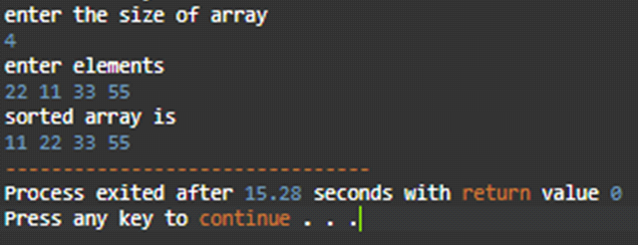

**Implementation of Selection sort**

#include<stdio.h>

int main()

{

int a[100],n,min,minIndex;

printf("enter no. of elements\n");

scanf("%d",&n);

printf("enter elements\n");

for(int i=0;i<n;i++){

scanf("%d",&a[i]);

}

for(int i=0;i<n;i++){

min=a[i];

minIndex=i;

for(int j=i+1;j<n;j++){

if(a[j]<min){

min=a[j];

minIndex=j;

}

}

a[minIndex]=a[i];

a[i]=min;

}

// printing of sorted final array

printf("sotred array:\n");

for(int i=0;i<n;i++){

printf("%d ",a[i]);

}

}

output

